Ryan Erickson

Spring 2014

22C:019 Homework 2

∧∨Å →↔∃∀

Page 152-153

4a. domain : Set of non-negative integers Z – Z-

range: {0,1,2,3,4,5,6,7,8,9}

6b. domain: set of positive integers

range: {0,1,2,3,4,5,6,7,8,9}

14b. not onto

22d. f(x) = (x^5)+1 is a bijection

Page 154-155

36. f o g = (x^2)+4x+5

g o f = (x^2) + 3

42c. R-{-2,2}

68d.

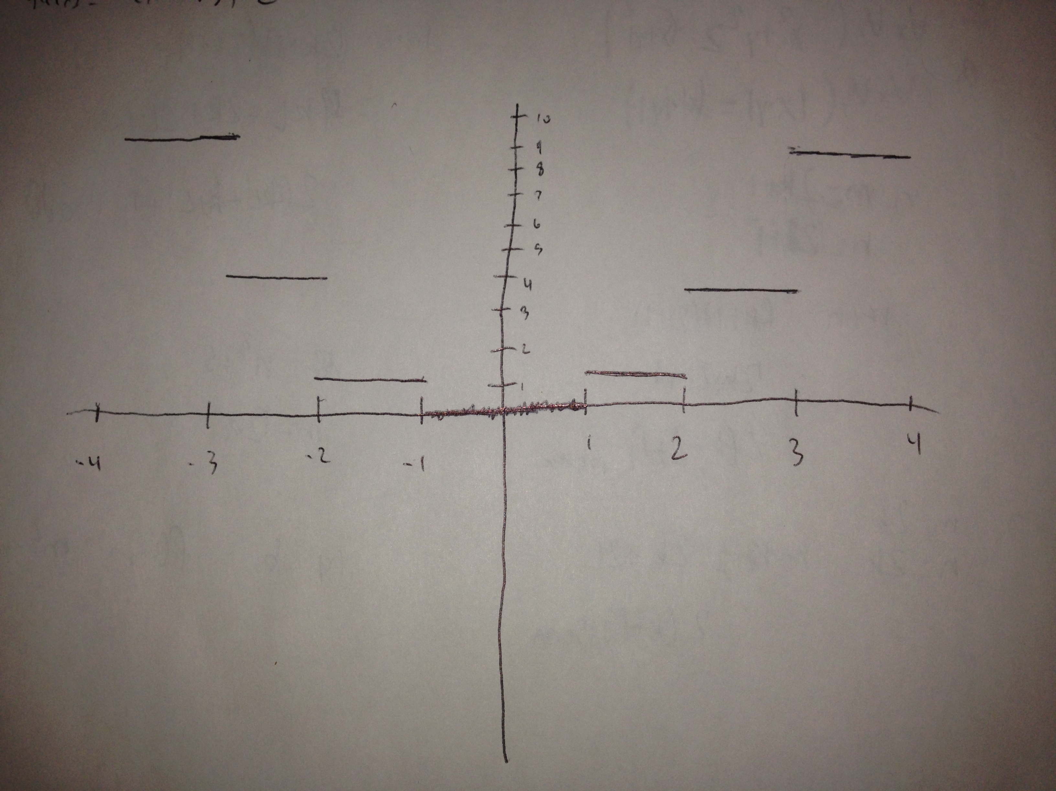

Page 167

4d. a_0 = 2; a_1 = 0; a_2 = 8; a_3 = 0

8.

1) a_0 = 1; a_1 = 2 + a_0; a_2 = a_1 + 2; a_3 = a_2 + 2; Fibonacci sequence

2) { 2n+1}; arithmetic progression

3) n = 2; a_3 = a_2 + a_1 – 1; recurrence formula

Page 168-169

16c. a_n = 4 – ((n(n+1))/2)

20a. P_0 = 6.9; P_n = (1.011)P_(n-1)

b.((1.011)^n)6.9

26c.

2^0, 2^1, 2^2, …, 2^(n-1)

2^(c-1) with 1 on the left and 2^(c-1) with 0

a_n = n

f. a_n = (2n-1)

34d. 180

40. 380477799